**Spectrum Lab**

Use the spectroscopes to view the halogen source and the gas tubes. Draw what you see. *Note: The spectroscopes are marked with 4, 5, 6, etc. This corresponds to wavelengths of 4000, 5000, 6000, etc. on the graphs below.*

**Halogen source**

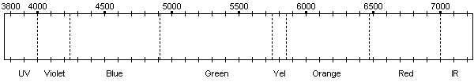

**Gas Tube 1**



**Gas Tube 2**



**Gas Tube 3**



**Gas Tube 4**

